SOS Water Wellness Data Charts 2024
Samples Taken by: Ann Ghyzel, Nell Gardner & Dennis Chasse
Substitutes: Janet Maitland, Jay Maitland & Mary Ann Edwards
Observations by: Farmer Gardner
Instrument used: Hanna Instruments model #HI98199 Multiparameter Meter pH/mV, EC, Dissolved Oxygen & Temperature, HI3874 Nitrate Test Kit and HI3833 Phosphate Test Kit.
Locations:
Sodus Bay, surface water, water depth ~ 2-4 ft:
1st Creek
2nd Creek
3rd Creek
Bay Bridge
Oak Park
Lake Bluff

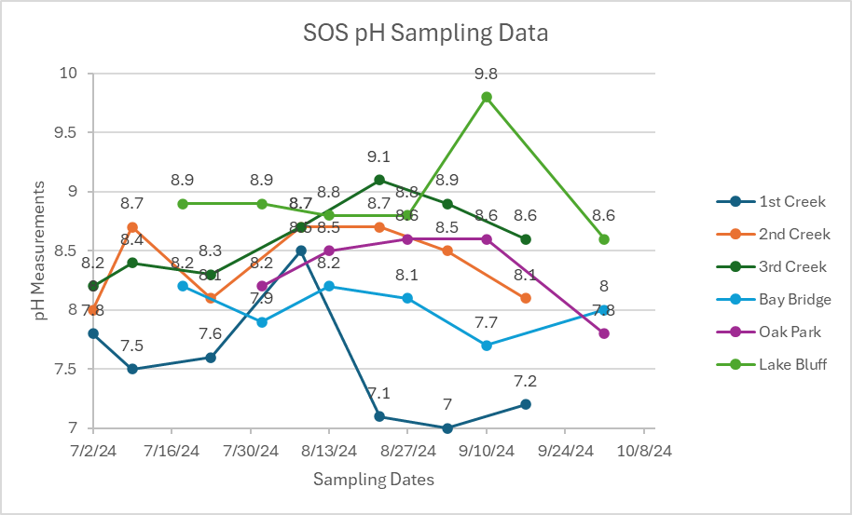

Note: Most fish prefer pH range from 6-9.

Note: High conductivity (1000s of uS/cm) indicates the water is salty or contaminated with chemicals

Note: Water temperature affects the growth of plants and the amount of dissolved oxygen

Note: Dissolved oxygen <5 ppm can negatively affect fish. Dissolved oxygen decreases as water temperature increases.

SOS Phosphate Data (ppm)

Note: Our sampling kits were on back order, so the 2024 data is limited.
Date | Location | Phosphate (ppm)
9/17/24 | 1st Creek | <1
10/11/24 | 1st Creek | <1
10/11/24 | 2nd Creek | <1
10/11/24 | 3rd Creek | <1
9/10/24 | Bay Bridge | <1
10/1/24 | Bay Bridge | 5
9/10/24 | Oak Park | <1
10/1/24 | Oak Park | <1
9/10/24 | Lake Bluff | <1
10/1/24 | Lake Bluff | 5
10/11/24 | Lake Bluff | <1

High levels of phosphate will over fertilize the water and can cause rapid weed growth & algae blooms. Sources of excess phosphate can be found in fertilizers, leaking septic systems and soil sediment.

SOS Nitrate Data (ppm)
Note: Our sampling kits were on back order, so the 2024 data is limited.
Date | Location | Nitrate (ppm)
9/17/24 | 1st Creek | <10
10/11/24 | 1st Creek | <10
10/11/24 | 2nd Creek | <10
10/11/24 | 3rd Creek | <10
9/10/24 | Bay Bridge | <10
10/1/24 | Bay Bridge | <10
9/10/24 | Oak Park | <10
10/1/24 | Oak Park | <10
9/10/24 | Lake Bluff | <10
10/1/24 | Lake Bluff | <10
10/11/24 | Lake Bluff | <10

High levels of nitrate can cause rapid weed growth & algae blooms, low levels of oxygen in the water and can directly harm aquatic animals. The most significant source of freshwater nitrates in NYS is agricultural fertilizer runoff, leaking septic systems is also a possible source.

